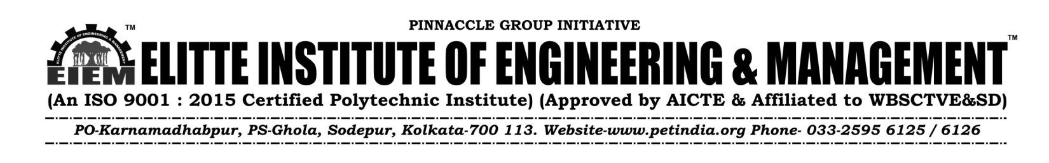
NOTICE 23.11.22

All the Students of Diploma -3rd Year (2022-23) , are hereby informed that the college Uniform will be supplied by our enlisted vendor M/s Adi Readymade Cr Pvt Ltd from our college campus---On 25.11.22, C, Block, 3rd Fl, From12pm – To 4 p.m;
Students are hereby requested to purchase Uniform( T-Shirt & Trousers) directly from the “M/s Adi Readymade Cr Pvt Ltd, from college campus only.
For any other information regarding Uniform, feel free to contact with the undersigned.

For Elitte Institute of Engineering & Management

Biswajit Dutta
Manager- Logistic & Maintenance
M-9163316558
Copy to:
- The Director
- Secretary-P.E.T
- Officer- in- Charge
- Principal office
- All HODs
- Website
- Student support Cell
- Students Notice Board

