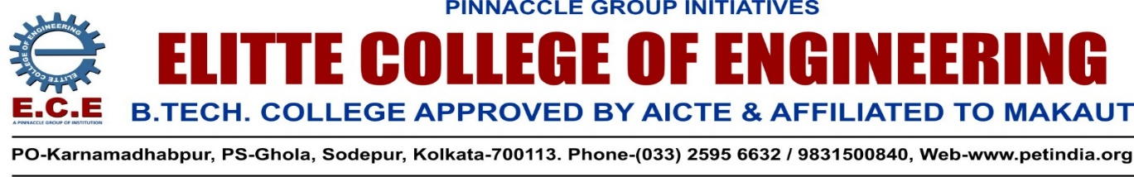
IA CINIC- ELITTE COLLEGE OF ENGINEERING (ECE)
NOTICE
Ref. IIC/ECE/IA/Clinic/2022/01 Dt. 6th March,2022

This is to inform all concerned that IIC-ECE is going to start Innovation Ambassador Clinic (IA Clinic) as per the recommendation of Ministry of Education’s Innovation Cell from 9th March,2022 at IIC Centre, 2nd floor, A-Block, ECE. The clinic will operate on every Wednesday and Thursday from 3.00—4.00 pm. Dr.Sirshendu Sekhar Ghosh and Sri Surajit Saha, both accredited Innovation Ambassadors, ECE will be the resource persons of the Clinic. The objective of the clinic is, assisting the students and faculties of the College on innovation and startup by counseling, discussing innovative ideas, making them aware of different Govt. schemes and financial supports, helping them to apply for patent and taking them towards manufacturing process. The Clinic will arrange different in-house competition, seminars, webinars and other activities to encourage innovation among the students and faculties.
Dr. B.G.Gupta,
President, IIC,ECE
HOD-CE/ECE

Copy for information to:

1. All B. Tech students of 1st, 2nd, 3rd and 4th year.
2. All faculty members through HODs
3. Director (A & HR) – for kind info. please
4. Director (O) – for kind info. Please
5. Mr. Sankar Ray – Manager, Coordination – for kind info. Please
6. Mr.Biswajit Das—In -Charge, Store( ECE&EIEM)
6. Mr. Tathagata Roy Chowdhury – for doing the needful please.

