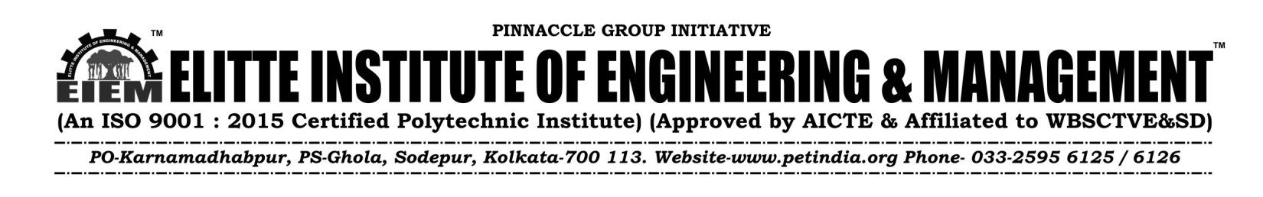
NOTICE 17.11.23

All the Students of Diploma -1st Year (2023-24) , are hereby informed that the college Uniform will be supplied by our enlisted vendor M/s Adi Readymade Cr Pvt Ltd from our college campus--- from 21.11.23 to 22.11.23 ,at C Block, 3rd Fl, (Timings-12pm -4 p.m);
Students are hereby requested to purchase Uniform directly from the “M/s Adi Readymade Cr Pvt Ltd, after the full payment of Rs 2500/- for the Full set : 2 Nos of T-Shirt & 2 Nos of Trousers. (Those who have already deposited , will only bring the Money Receipt)
For any other information regarding Uniform, feel free to contact with the undersigned.

For Elitte Institute of Engineering & Management

Biswajit Dutta
Manager- Logistic & Maintenance
M-9163316558
Copy to:
- The Director
- Secretary-P.E.T
- Officer- in- Charge
- Principal office
- Departmental HODs
- Website
- Students Notice Board

