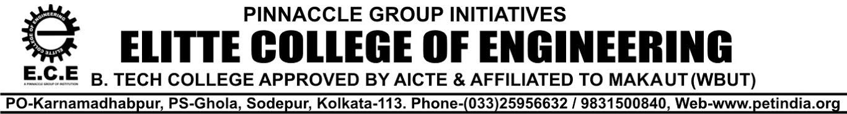
NOTICE 28.11.23

All the Students of BTECH 1st,2nd,3rd , 4th & MBA 1ST & 2nd YR- (2023-24 ), are hereby informed that the college Uniform will be supplied by our enlisted vendor M/s Adi Readymade Cr Pvt. Ltd. , from our college campus from 29.11.23 to 01.12.23 at C Block 2nd Floor,(Timings-12 pm to 4 p.m)
Students are hereby requested to purchase Uniform directly from the “M/s Adi Readymade Cr Pvt Ltd, after the full payment of Rs 2500/- for the Full set : 2 Nos of T-Shirt / Shirt & 2 Nos of Trousers. (Those who have already deposited , will only bring the Money Receipt)
For any other information regarding Uniform, feel free to contact with the undersigned.

For Elitte College of Engineering

Biswajit Dutta
Manager- Logistic & Maintenance
M-9163316558
Copy to:
- The Director
- Secretary-P.E.T
- Officer- in- Charge
- Principal office
- Departmental HODs
- Website
- Students Notice Board

