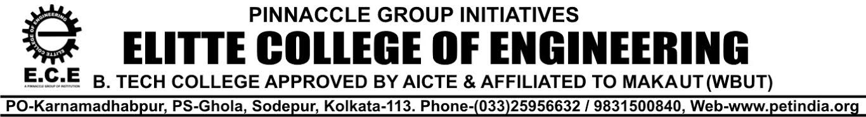
NOTICE 04.10.23

All the Students of 1ST; 2nd ,3rd & 4TH Year (2023-24) , are hereby informed that the college Uniform will be supplied by our enlisted vendor M/s Adi Readymade Cr Pvt Ltd( Station Road, Sodepur) from our college campus.
Students are hereby requested to deposit Rs 2500/-(approx.) to our Accounts Dept. within 12 .10.23
for the Full set : 2 Nos of T-Shirt/Shirt & 2 Nos of Trousers.
For any other information regarding Uniform, feel free to contact with Logistic & Maintenance Dept.
Your Cooperation in this regard is highly appreciated

For Elitte College of Engineering
Biswajit Dutta
Manager- Logistic & Maintenance
Copy to:
- The Director
- Secretary-P.E.T
- Officer- in- Charge
- Accounts Dept.
- Principal office
- Website

